# **Exercise – D3 Data Visualization using TreeMap**

**Student Name: Pulkit Agrawal Student Id: PXA180017**

**Date: 11-30-2018**

**Question:**

1. **Open your HTML page in WEB browser and take a screen shot of your page showing page Title (your name) and page background.**

**Answer**

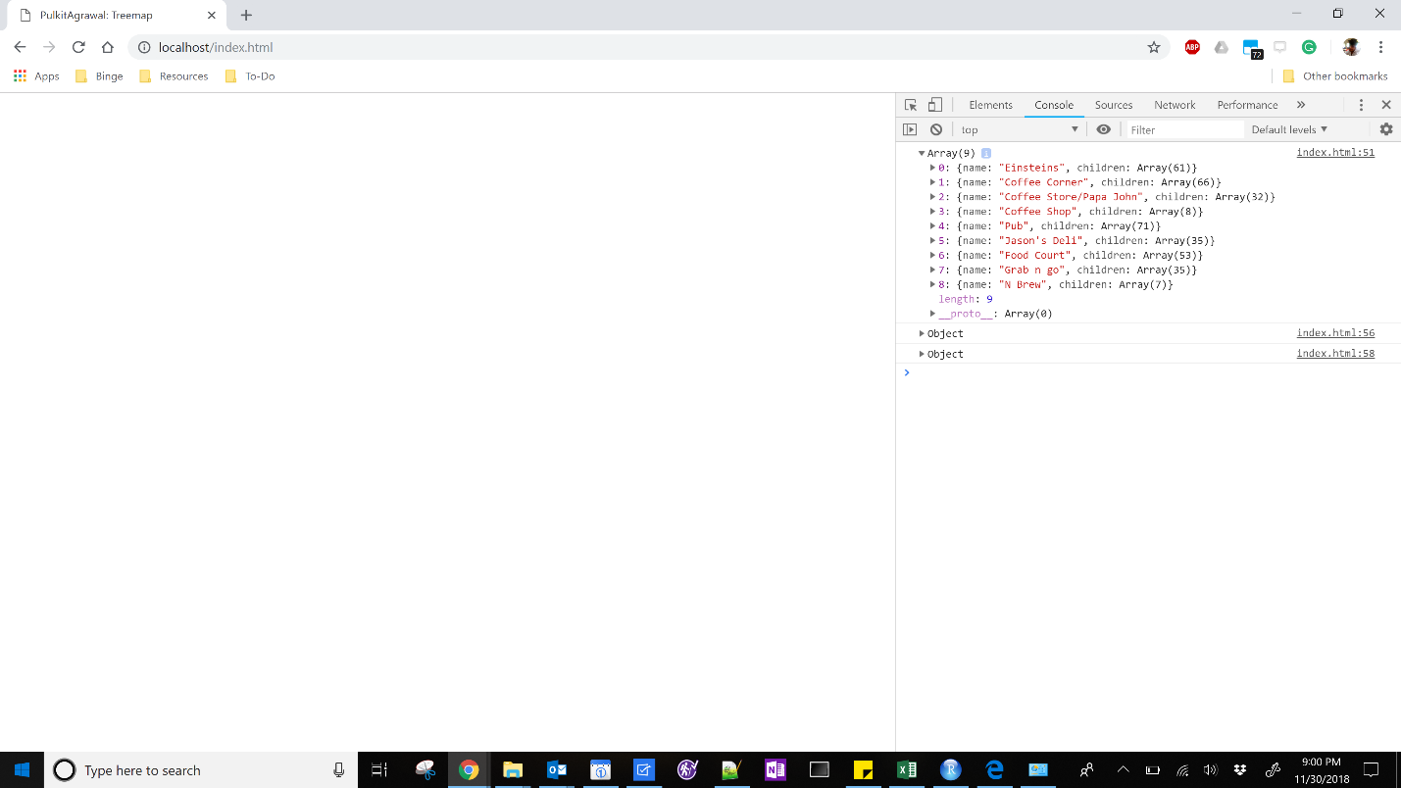

**Question**

1. **Paste a screenshot**

**Answer:**

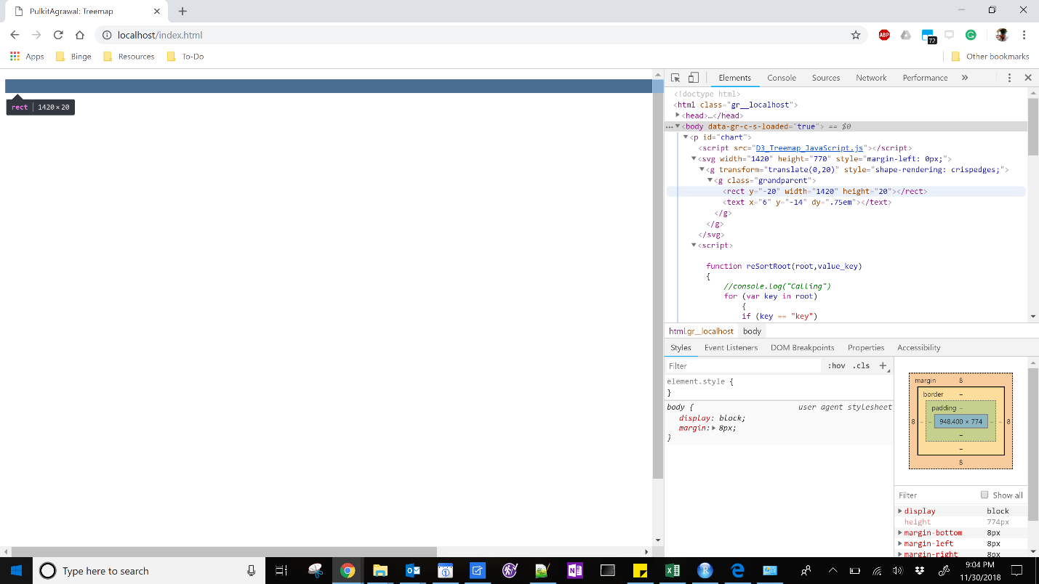

**Question:**

1. **Open the web browser, open your web page and paste the screen shot of your page.**

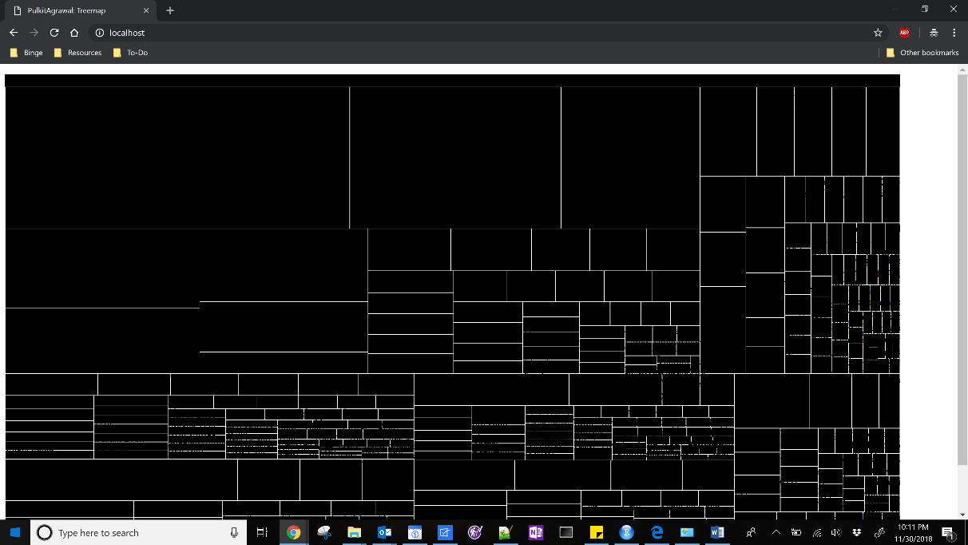

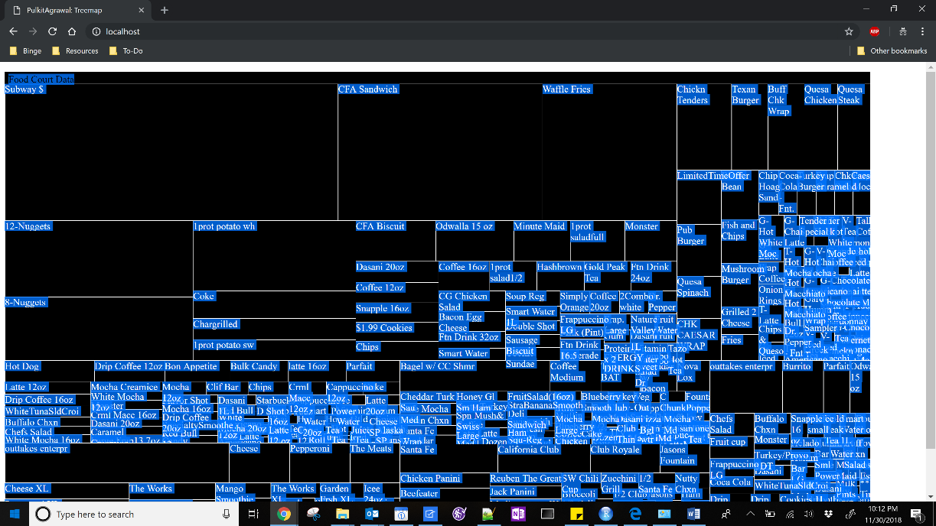

**Question:**

1. **Open the web browser, open your web page and paste the screen shot of your page.**

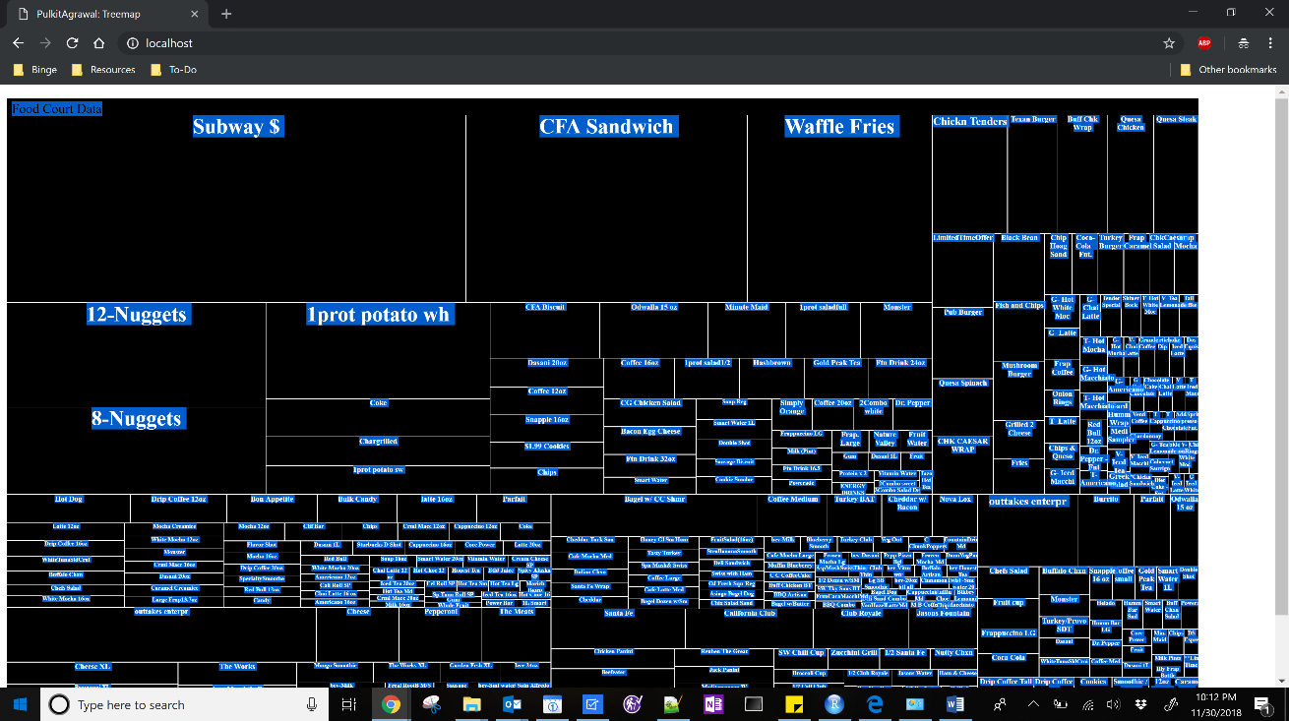

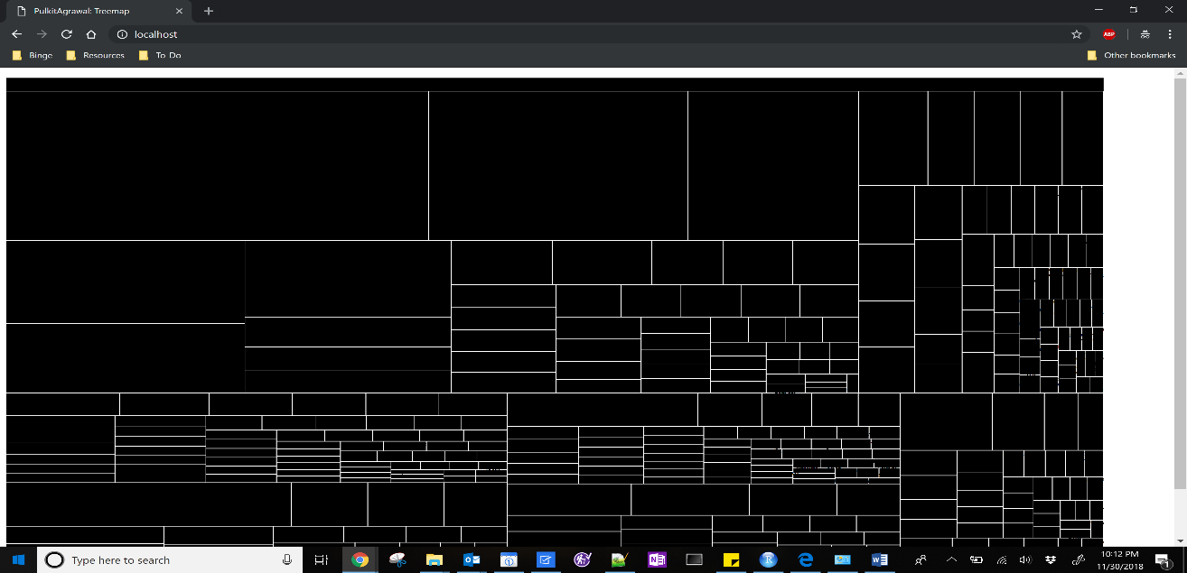

**Question:**

1. **Open the web browser, open your web page and paste the screen shot of your page.**

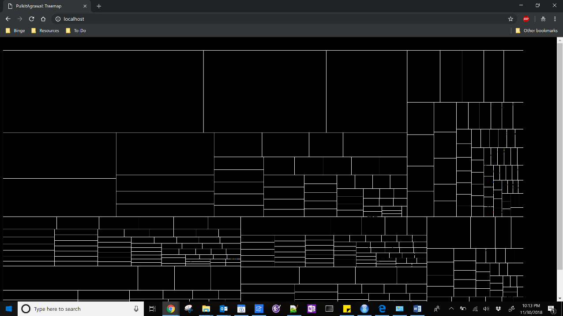

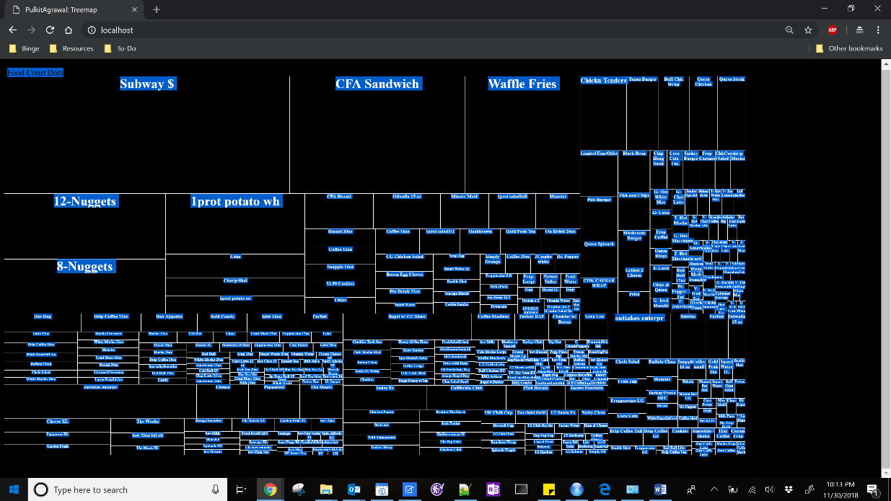

**Question:**

1. **Open the web browser, open your web page and paste the screen shot of your page.**

**Answer**

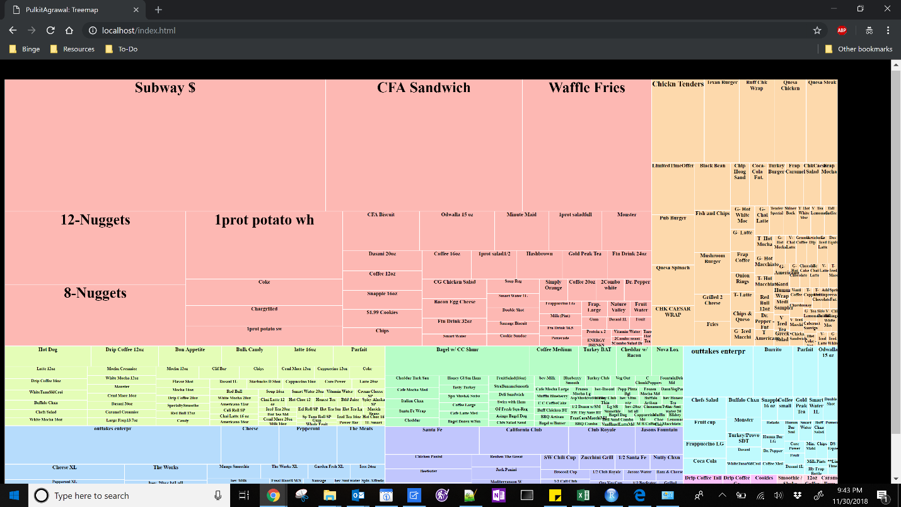

**Question:**

1. **Open the web browser, open your web page and paste the screen shot of your page.**

**Answer**

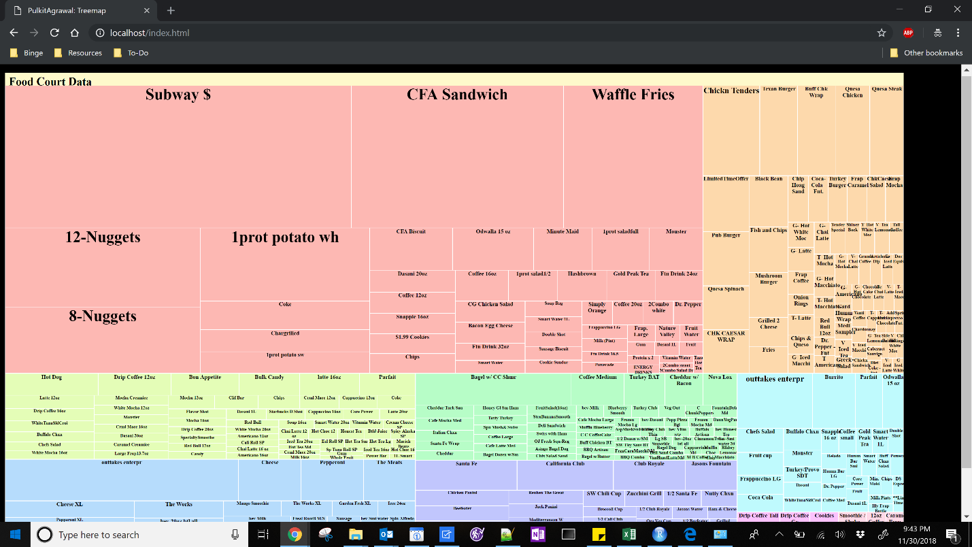

**Question:**

1. **Open the web browser, open your web page and paste the screen shot of your page.**

**Answer**

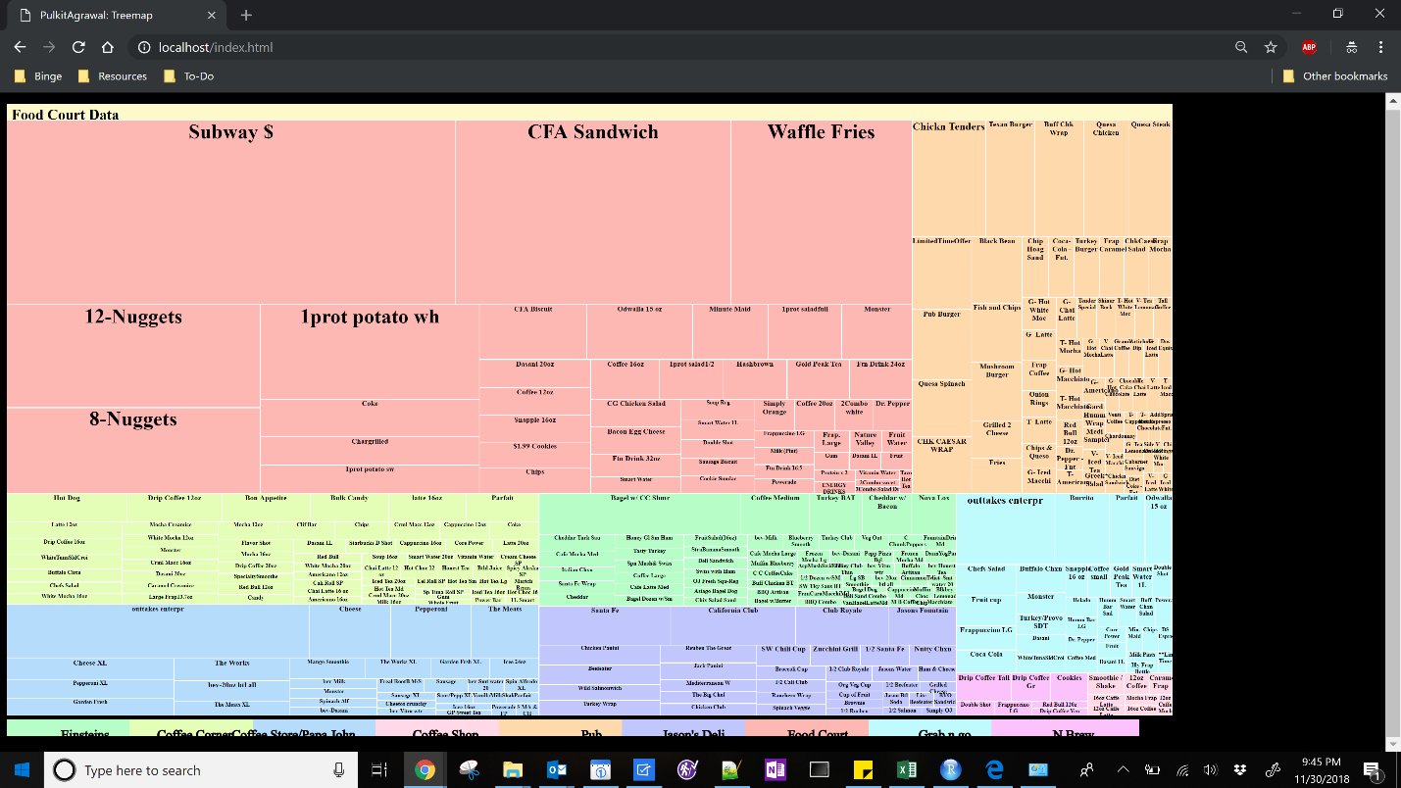

**Question:**

1. **Open the web browser, open your web page and paste the screen shot of your page.**

**Answer**

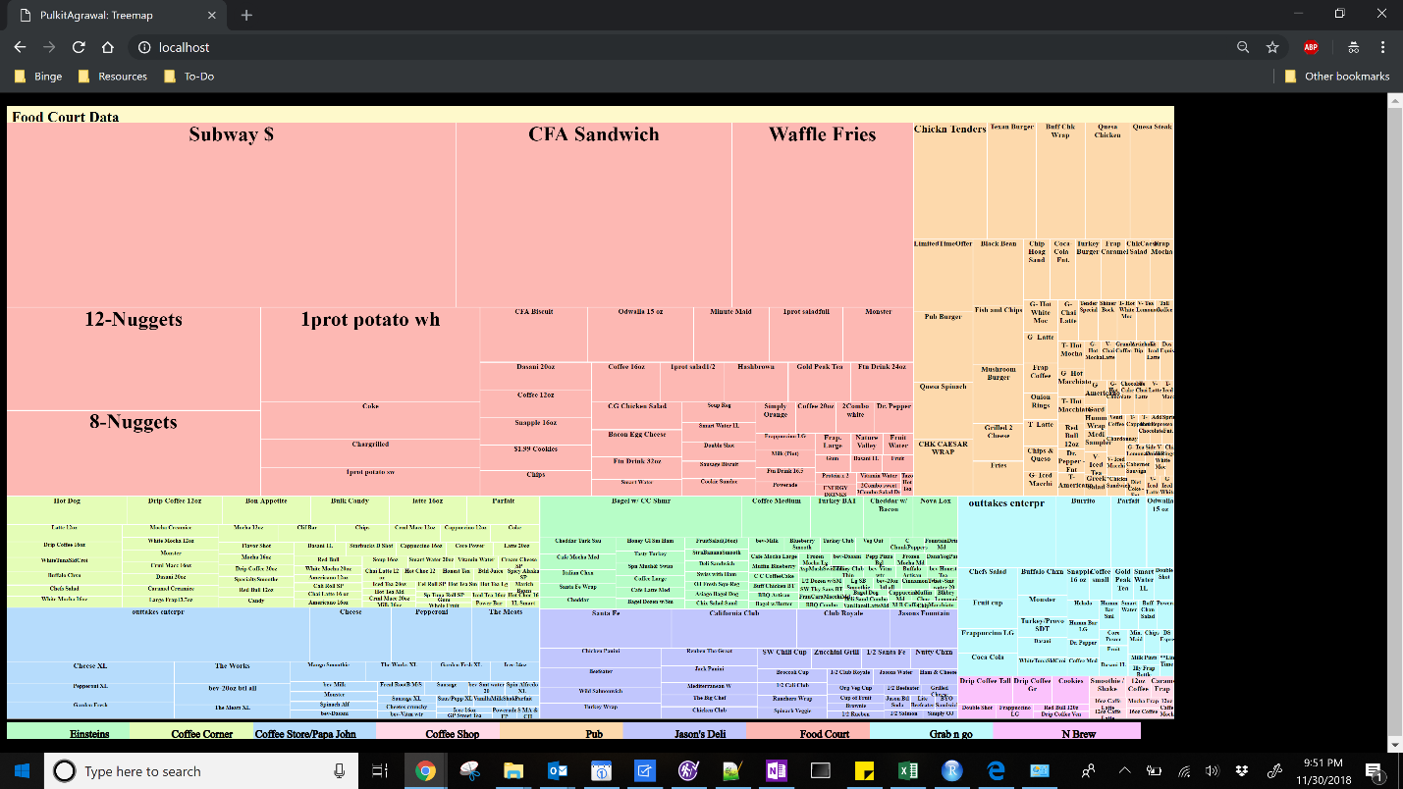

**Question:**

1. **Open the web browser, open your web page, click anywhere in the rectangle Coffee Store/Papa John. Paste the screen shot after navigating to the respective children of the rectangle.**

**Answer**

